DIAGRAMS FOR LIBRARY MANAGEMENT DIAGRAM:

USE CASE DAIGRAM :

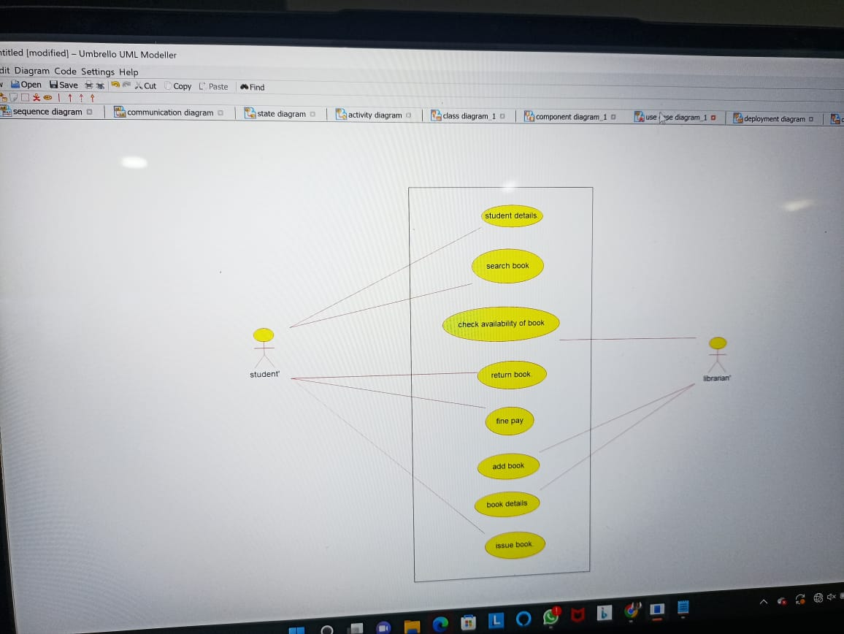

DEPLOYMENT DAIGRAM:

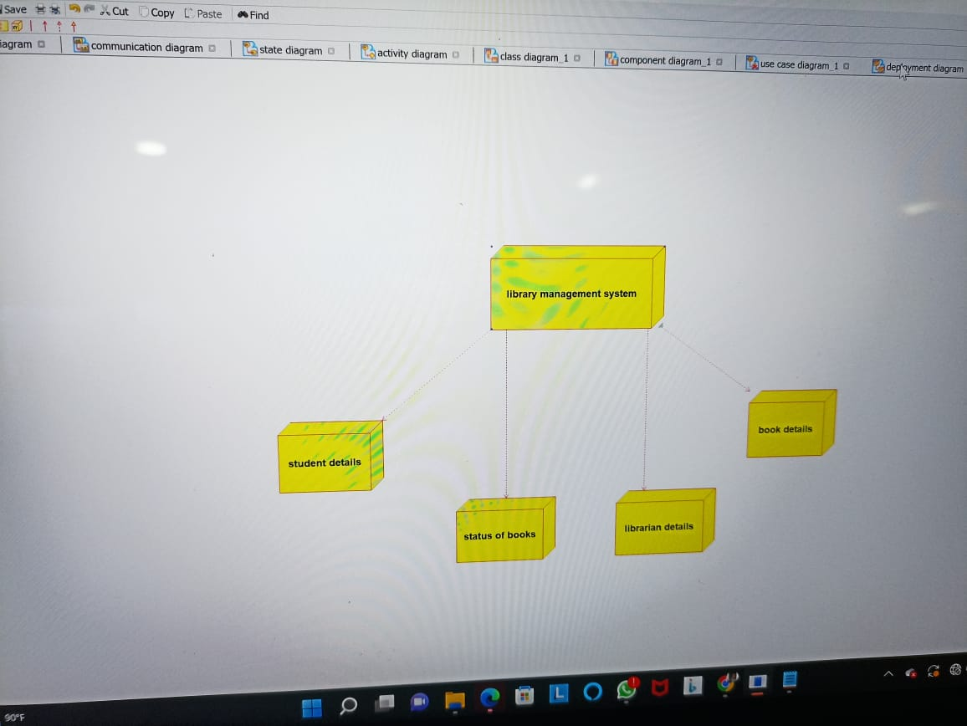

COMPONENT DAIGRAM

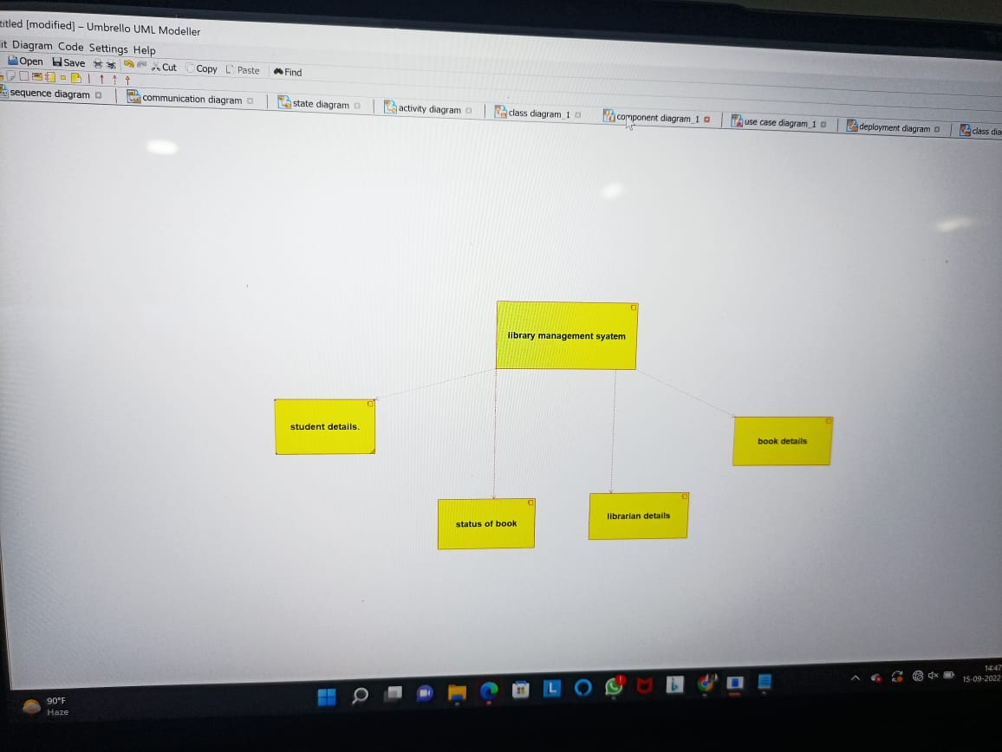

ACTIVITY DAIGRAM

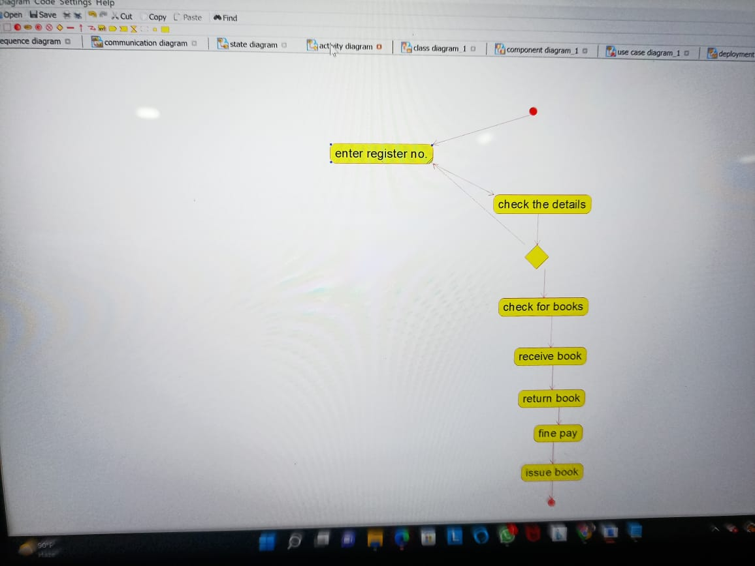

STATECHART DAIGRAM

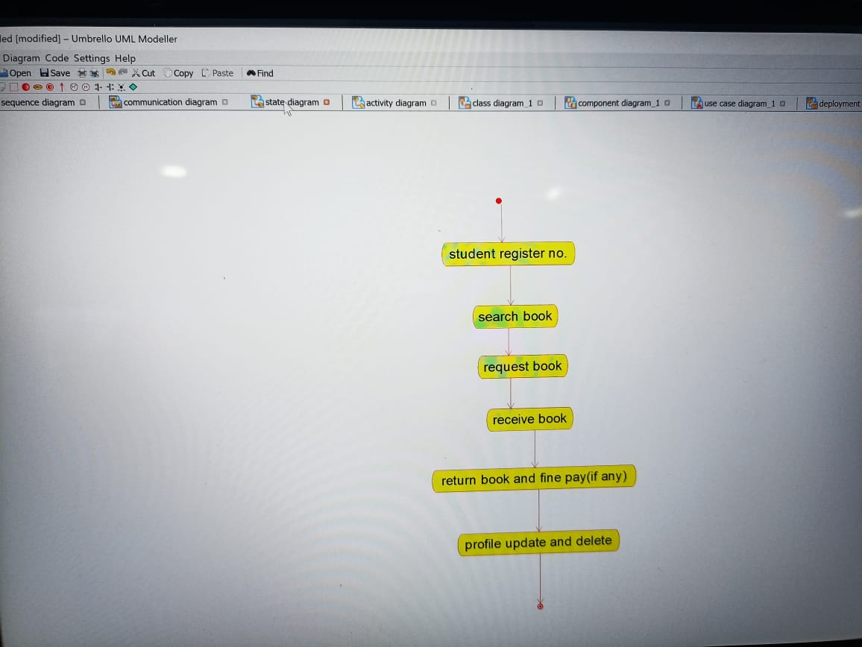

SEQUENCE DAIGRAM

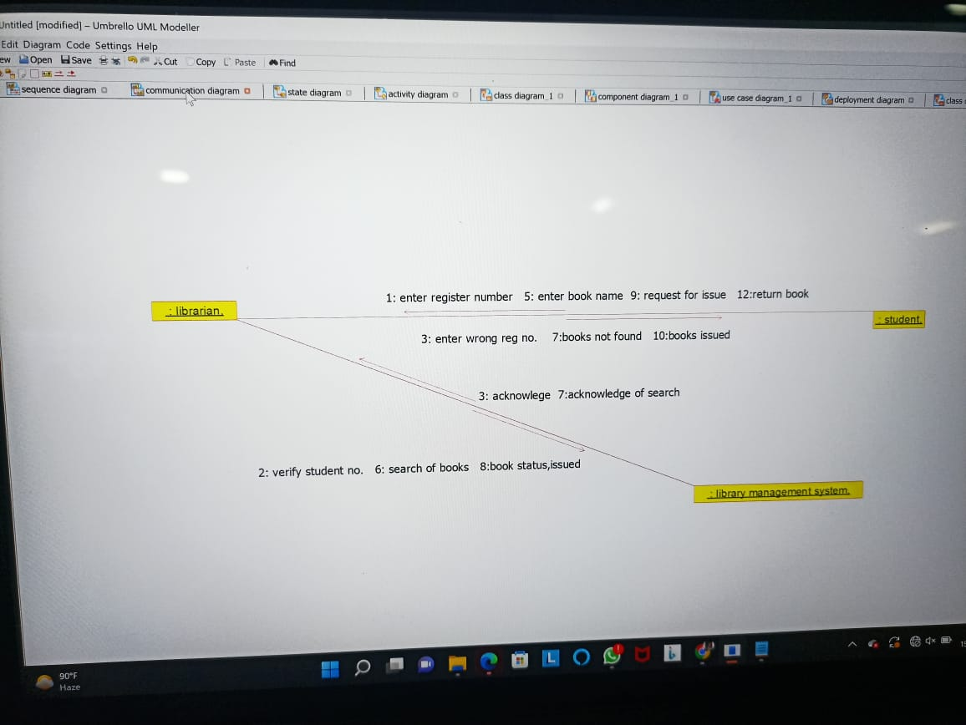

PACKAGE DAIGRAM

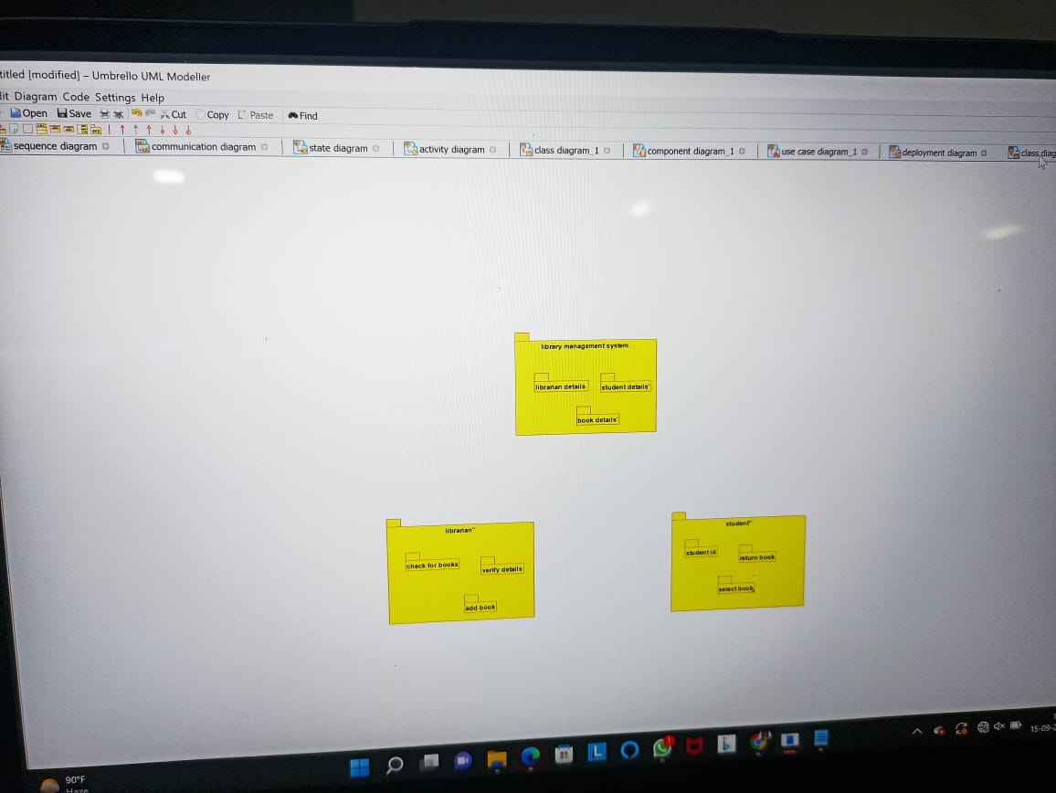

COLLABRATION DAIGRAM



CLASS DAIGRAM

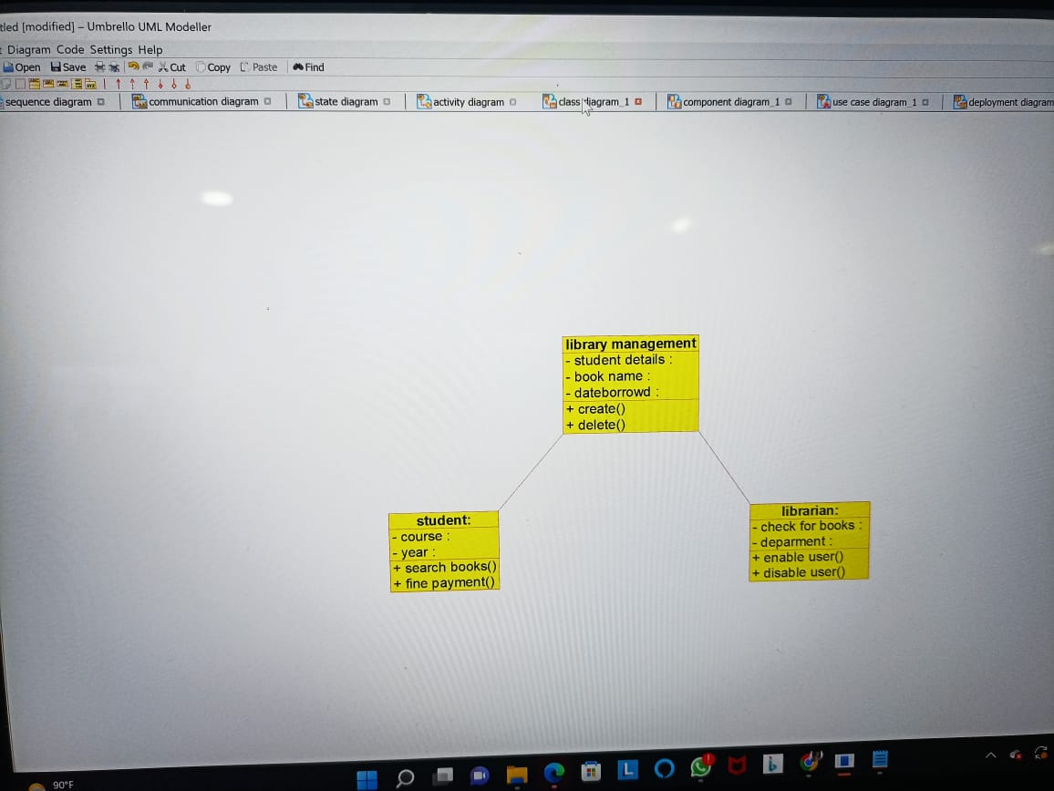

LIBRARY MANAGEMENT SYSTEM

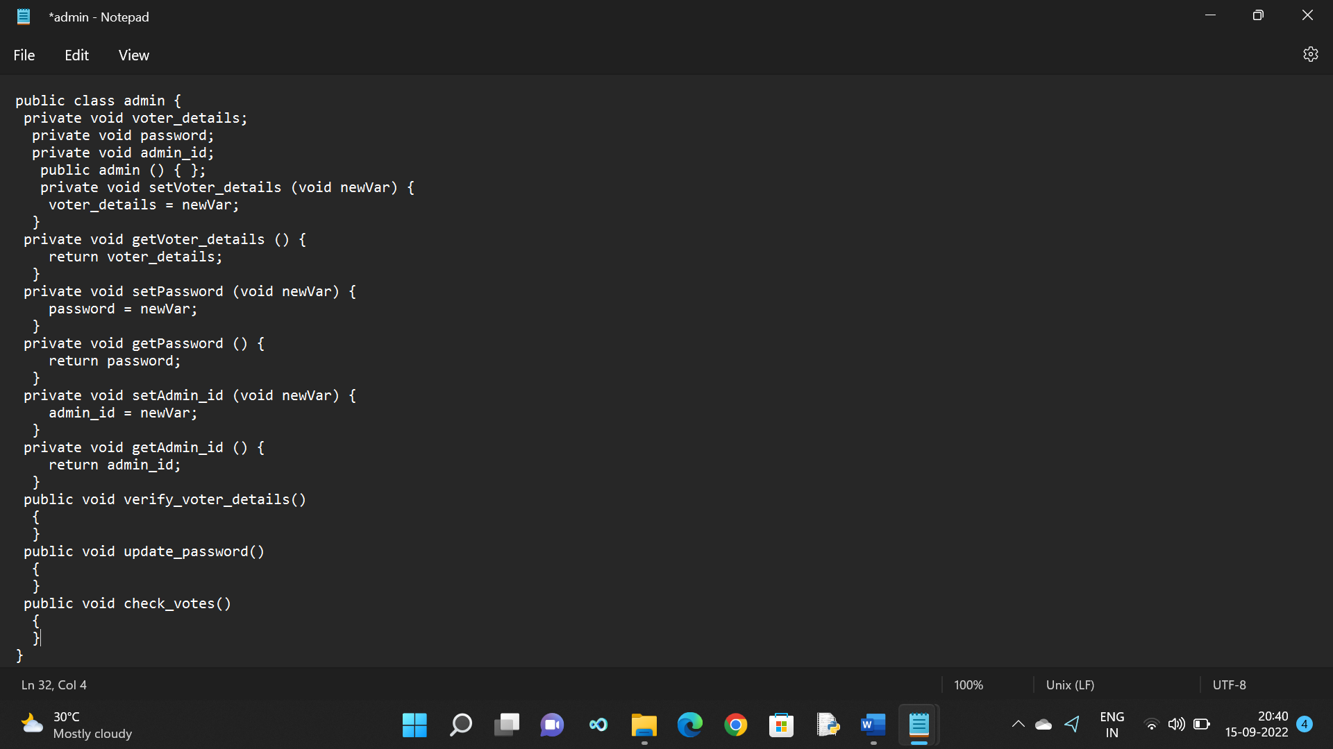

LIBRARIAN

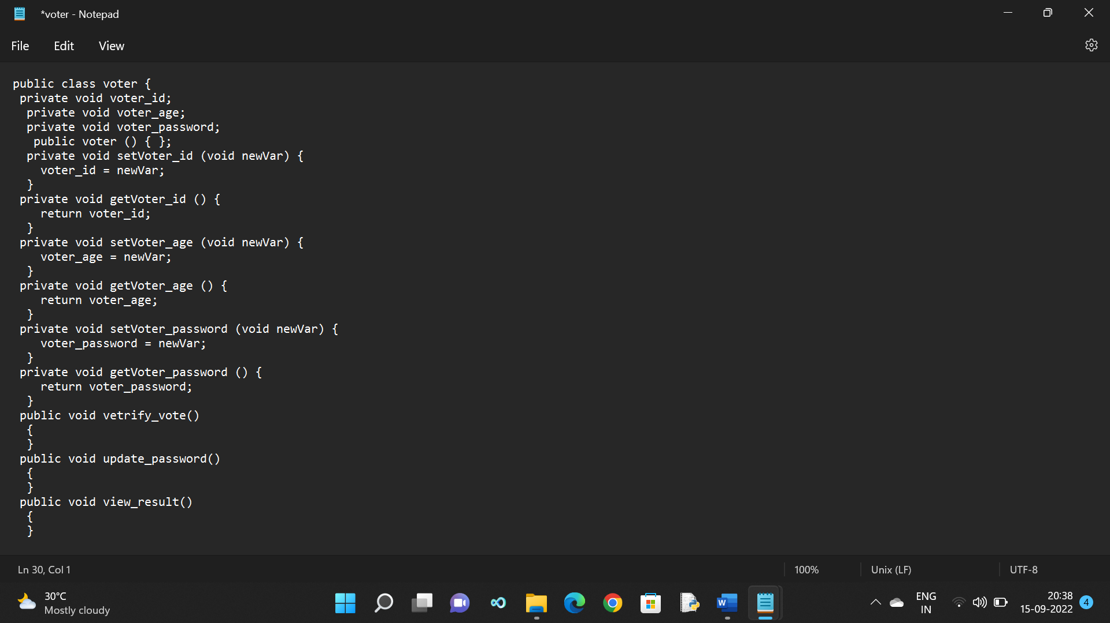

STUDENT

